Day #9 – Small Business Programs

Congrats! You made it halfway! Keep on pushing!

Did you dig deep yesterday? Do you have the hustle and grit and burning desire? I sure hope so.

Get ready to learn about the different programs that are tailored to make you extraordinary in the government contracting arena.

Click below to start todays lesson.

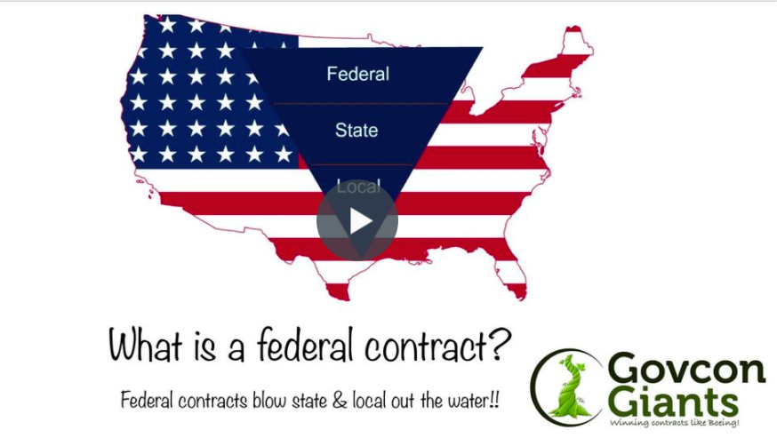

In today’s assignment I will take you on a journey to discover your business.

Step aboard my rocket ship!

Big hug,

Eric Coffie

